Sequential Adder

Introduction:
we have to make 4-bit sequential adder in which we are getting serial input and output is also serial. So we now we have to make FSM for this task.

FSM:
we have to make in the way that after adding 4 bit number the machine returns to its 1 state.
So for this we have to store 4 numbers this will require 2 bits and 1 bit more for carry of each number so now we have 3 bits that require 2³ = 8 states
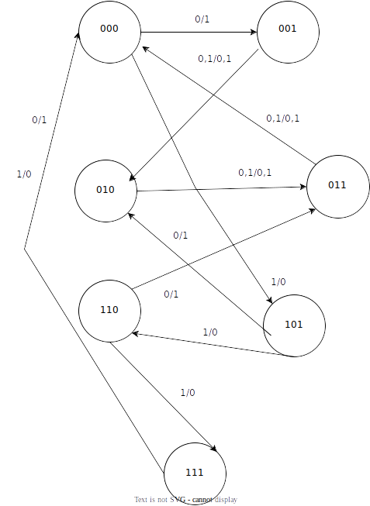

after state reduction the states are only 7. we have add 1 in the very first number as we have to increment the whole number.

Wave:

Explanation:
the wave is showing the clock,input,output,reset, and current states.
I have given three 4 bit numbers and after adding it is returning to the first state every time.

